Preparing undergraduate biology students to bridge ideological divides with science communication
Erin Rowland-Schaefer, Ph.D. | M. Elizabeth Barnes, Ph.D. | Isaiah Aduse-Poku | Jamie Jensen, Ph.D.

Questions to Consider
- What would you need to feel prepared and motivated to include instruction on interpersonal communication across ideological divides in your classroom?

- What research questions do you most want answered about teaching students to communicate across ideological divides?

- How might researchers best support instructors in implementing instruction in their classrooms?

Resources
A collection of the literature cited and resources for instructors can be found at github.com/erowland21/NABT-2020-Scicomm-Resources or by scanning this QR Code!
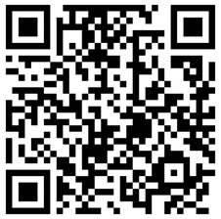

Help Us Continue This Work!
Scan the QR code below to take a brief (5 minute) survey answering the questions above and reporting if you would be willing to incorporate instruction on interpersonal science communication in your classroom as part of research efforts!
